Names: Helen Kim, Dominic Lee

Data Model:

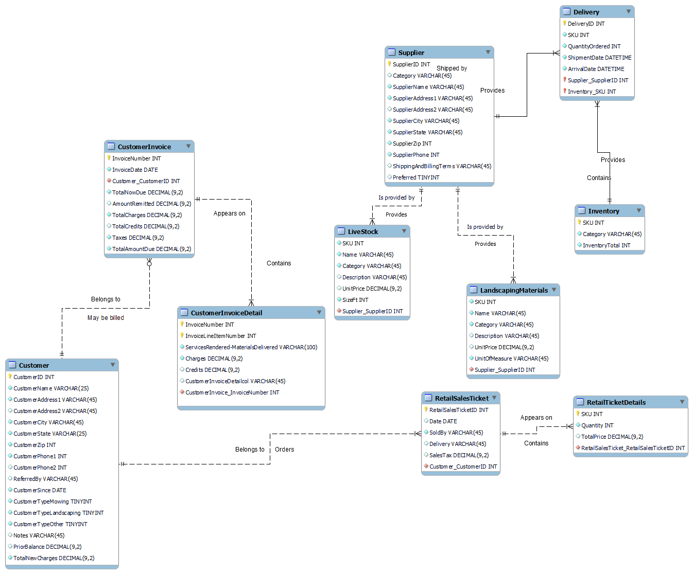

DDL:

-- MySQL Workbench Forward Engineering

SET @OLD_UNIQUE_CHECKS=@@UNIQUE_CHECKS, UNIQUE_CHECKS=0;

SET @OLD_FOREIGN_KEY_CHECKS=@@FOREIGN_KEY_CHECKS, FOREIGN_KEY_CHECKS=0;

SET @OLD_SQL_MODE=@@SQL_MODE, SQL_MODE='ONLY_FULL_GROUP_BY,STRICT_TRANS_TABLES,NO_ZERO_IN_DATE,NO_ZERO_DATE,ERROR_FOR_DIVISION_BY_ZERO,NO_ENGINE_SUBSTITUTION';

-- -----------------------------------------------------

-- Schema mydb

-- -----------------------------------------------------

-- -----------------------------------------------------

-- Schema mydb

-- -----------------------------------------------------

CREATE SCHEMA IF NOT EXISTS `mydb` DEFAULT CHARACTER SET utf8 ;

-- -----------------------------------------------------

-- Schema EdenLandscaping

-- -----------------------------------------------------

-- -----------------------------------------------------

-- Schema EdenLandscaping

-- -----------------------------------------------------

CREATE SCHEMA IF NOT EXISTS `EdenLandscaping` DEFAULT CHARACTER SET latin1 ;

-- -----------------------------------------------------

-- Schema edenlandscaping

-- -----------------------------------------------------

USE `mydb` ;

-- -----------------------------------------------------

-- Table `mydb`.`Customer`

-- -----------------------------------------------------

CREATE TABLE IF NOT EXISTS `mydb`.`Customer` (

`CustomerID` INT NOT NULL AUTO_INCREMENT,

`CustomerName` VARCHAR(25) NOT NULL,

`CustomerAddress1` VARCHAR(45) NOT NULL,

`CustomerAddress2` VARCHAR(45) NULL,

`CustomerCity` VARCHAR(45) NOT NULL,

`CustomerState` VARCHAR(25) NOT NULL,

`CustomerZip` INT NOT NULL,

`CustomerPhone1` INT NOT NULL,

`CustomerPhone2` INT NULL,

`ReferredBy` VARCHAR(45) NULL,

`CustomerSince` DATE NOT NULL,

`CustomerTypeMowing` TINYINT NOT NULL,

`CustomerTypeLandscaping` TINYINT NOT NULL,

`CustomerTypeOther` TINYINT NOT NULL,

`Notes` VARCHAR(45) NULL,

`PriorBalance` DECIMAL(9,2) NULL,

`TotalNewCharges` DECIMAL(9,2) NOT NULL,

PRIMARY KEY (`CustomerID`))

ENGINE = InnoDB;

-- -----------------------------------------------------

-- Table `mydb`.`CustomerInvoice`

-- -----------------------------------------------------

CREATE TABLE IF NOT EXISTS `mydb`.`CustomerInvoice` (

`InvoiceNumber` INT NOT NULL,

`InvoiceDate` DATE NOT NULL,

`Customer_CustomerID` INT NOT NULL,

`TotalNowDue` DECIMAL(9,2) NOT NULL,

`AmountRemitted` DECIMAL(9,2) NULL,

`TotalCharges` DECIMAL(9,2) NOT NULL,

`TotalCredits` DECIMAL(9,2) NULL,

`Taxes` DECIMAL(9,2) NOT NULL,

`TotalAmountDue` DECIMAL(9,2) NOT NULL,

PRIMARY KEY (`InvoiceNumber`),

INDEX `fk_Invoice_Customer_idx` (`Customer_CustomerID` ASC) VISIBLE,

CONSTRAINT `fk_Invoice_Customer`

FOREIGN KEY (`Customer_CustomerID`)

REFERENCES `mydb`.`Customer` (`CustomerID`)

ON DELETE NO ACTION

ON UPDATE NO ACTION)

ENGINE = InnoDB;

-- -----------------------------------------------------

-- Table `mydb`.`CustomerInvoiceDetail`

-- -----------------------------------------------------

CREATE TABLE IF NOT EXISTS `mydb`.`CustomerInvoiceDetail` (

`InvoiceNumber` INT NOT NULL,

`InvoiceLineItemNumber` INT NOT NULL,

`ServicesRendered-MaterialsDelivered` VARCHAR(100) NOT NULL,

`Charges` DECIMAL(9,2) NOT NULL,

`Credits` DECIMAL(9,2) NULL,

`CustomerInvoiceDetailcol` VARCHAR(45) NULL,

`CustomerInvoice_InvoiceNumber` INT NOT NULL,

PRIMARY KEY (`InvoiceNumber`, `InvoiceLineItemNumber`),

INDEX `fk_CustomerInvoiceDetail_CustomerInvoice1_idx` (`CustomerInvoice_InvoiceNumber` ASC) VISIBLE,

CONSTRAINT `fk_CustomerInvoiceDetail_CustomerInvoice1`

FOREIGN KEY (`CustomerInvoice_InvoiceNumber`)

REFERENCES `mydb`.`CustomerInvoice` (`InvoiceNumber`)

ON DELETE NO ACTION

ON UPDATE NO ACTION)

ENGINE = InnoDB;

-- -----------------------------------------------------

-- Table `mydb`.`Inventory`

-- -----------------------------------------------------

CREATE TABLE IF NOT EXISTS `mydb`.`Inventory` (

`SKU` INT NOT NULL,

`Category` VARCHAR(45) NOT NULL,

`InventoryTotal` INT NOT NULL,

PRIMARY KEY (`SKU`))

ENGINE = InnoDB;

-- -----------------------------------------------------

-- Table `mydb`.`LiveStock`

-- -----------------------------------------------------

CREATE TABLE IF NOT EXISTS `mydb`.`LiveStock` (

`SKU` INT NOT NULL,

`Name` VARCHAR(45) NOT NULL,

`Category` VARCHAR(45) NOT NULL,

`Description` VARCHAR(45) NULL,

`UnitPrice` DECIMAL(9,2) NULL,

`SizeFt` INT NOT NULL,

`Inventory_SKU` INT NOT NULL,

INDEX `fk_LiveStock_Inventory1_idx` (`Inventory_SKU` ASC) VISIBLE,

CONSTRAINT `fk_LiveStock_Inventory1`

FOREIGN KEY (`Inventory_SKU`)

REFERENCES `mydb`.`Inventory` (`SKU`)

ON DELETE NO ACTION

ON UPDATE NO ACTION)

ENGINE = InnoDB;

-- -----------------------------------------------------

-- Table `mydb`.`LandscapingMaterials`

-- -----------------------------------------------------

CREATE TABLE IF NOT EXISTS `mydb`.`LandscapingMaterials` (

`SKU` INT NOT NULL,

`Name` VARCHAR(45) NOT NULL,

`Category` VARCHAR(45) NOT NULL,

`Description` VARCHAR(45) NULL,

`UnitPrice` DECIMAL(9,2) NULL,

`UnitOfMeasure` VARCHAR(45) NOT NULL,

`Inventory_SKU` INT NOT NULL,

INDEX `fk_LandscapingMaterials_Inventory1_idx` (`Inventory_SKU` ASC) VISIBLE,

CONSTRAINT `fk_LandscapingMaterials_Inventory1`

FOREIGN KEY (`Inventory_SKU`)

REFERENCES `mydb`.`Inventory` (`SKU`)

ON DELETE NO ACTION

ON UPDATE NO ACTION)

ENGINE = InnoDB;

-- -----------------------------------------------------

-- Table `mydb`.`Supplier`

-- -----------------------------------------------------

CREATE TABLE IF NOT EXISTS `mydb`.`Supplier` (

`SupplierID` INT NOT NULL,

`Category` VARCHAR(45) NULL,

`SupplierName` VARCHAR(45) NOT NULL,

`SupplierAddress1` VARCHAR(45) NOT NULL,

`SupplierAddress2` VARCHAR(45) NULL,

`SupplierCity` VARCHAR(45) NOT NULL,

`SupplierState` VARCHAR(45) NOT NULL,

`SupplierZip` INT NOT NULL,

`SupplierPhone` INT NOT NULL,

`ShippingAndBillingTerms` VARCHAR(45) NULL,

`Preferred` TINYINT NULL,

PRIMARY KEY (`SupplierID`))

ENGINE = InnoDB;

-- -----------------------------------------------------

-- Table `mydb`.`RetailSalesTicket`

-- -----------------------------------------------------

CREATE TABLE IF NOT EXISTS `mydb`.`RetailSalesTicket` (

`RetailSalesTicketID` INT NOT NULL,

`Date` DATE NULL,

`SoldBy` VARCHAR(45) NOT NULL,

`Delivery` VARCHAR(45) NULL,

`SalesTax` DECIMAL(9,2) NULL,

`Customer_CustomerID` INT NOT NULL,

PRIMARY KEY (`RetailSalesTicketID`),

INDEX `fk_RetailSalesTicket_Customer1_idx` (`Customer_CustomerID` ASC) VISIBLE,

CONSTRAINT `fk_RetailSalesTicket_Customer1`

FOREIGN KEY (`Customer_CustomerID`)

REFERENCES `mydb`.`Customer` (`CustomerID`)

ON DELETE NO ACTION

ON UPDATE NO ACTION)

ENGINE = InnoDB;

-- -----------------------------------------------------

-- Table `mydb`.`RetailTicketDetails`

-- -----------------------------------------------------

CREATE TABLE IF NOT EXISTS `mydb`.`RetailTicketDetails` (

`SKU` INT NOT NULL,

`Quantity` INT NOT NULL,

`TotalPrice` DECIMAL(9,2) NULL,

`RetailSalesTicket_RetailSalesTicketID` INT NOT NULL,

PRIMARY KEY (`SKU`),

INDEX `fk_RetailTicketDetails_RetailSalesTicket1_idx` (`RetailSalesTicket_RetailSalesTicketID` ASC) VISIBLE,

CONSTRAINT `fk_RetailTicketDetails_RetailSalesTicket1`

FOREIGN KEY (`RetailSalesTicket_RetailSalesTicketID`)

REFERENCES `mydb`.`RetailSalesTicket` (`RetailSalesTicketID`)

ON DELETE NO ACTION

ON UPDATE NO ACTION)

ENGINE = InnoDB;

-- -----------------------------------------------------

-- Table `mydb`.`Delivery`

-- -----------------------------------------------------

CREATE TABLE IF NOT EXISTS `mydb`.`Delivery` (

`DeliveryID` INT NOT NULL,

`SKU` INT NOT NULL,

`QuantityOrdered` INT NOT NULL,

`ShipmentDate` DATETIME NOT NULL,

`ArrivalDate` DATETIME NOT NULL,

`Supplier_SupplierID` INT NOT NULL,

`Inventory_SKU` INT NOT NULL,

PRIMARY KEY (`DeliveryID`, `Supplier_SupplierID`, `Inventory_SKU`),

INDEX `fk_Delivery_Supplier1_idx` (`Supplier_SupplierID` ASC) VISIBLE,

INDEX `fk_Delivery_Inventory1_idx` (`Inventory_SKU` ASC) VISIBLE,

CONSTRAINT `fk_Delivery_Supplier1`

FOREIGN KEY (`Supplier_SupplierID`)

REFERENCES `mydb`.`Supplier` (`SupplierID`)

ON DELETE NO ACTION

ON UPDATE NO ACTION,

CONSTRAINT `fk_Delivery_Inventory1`

FOREIGN KEY (`Inventory_SKU`)

REFERENCES `mydb`.`Inventory` (`SKU`)

ON DELETE NO ACTION

ON UPDATE NO ACTION)

ENGINE = InnoDB;

USE `EdenLandscaping` ;

-- -----------------------------------------------------

-- Table `EdenLandscaping`.`Inventory`

-- -----------------------------------------------------

CREATE TABLE IF NOT EXISTS `EdenLandscaping`.`Inventory` (

`SKU` INT NOT NULL,

`Category` VARCHAR(45) NOT NULL,

`InventoryTotal` INT NOT NULL,

PRIMARY KEY (`SKU`))

ENGINE = InnoDB

DEFAULT CHARACTER SET = latin1;

-- -----------------------------------------------------

-- Table `EdenLandscaping`.`Livestock`

-- -----------------------------------------------------

CREATE TABLE IF NOT EXISTS `EdenLandscaping`.`Livestock` (

`Name` VARCHAR(45) NOT NULL,

`Category` VARCHAR(45) NOT NULL,

`Description` VARCHAR(45) NULL DEFAULT NULL,

`UnitPrice` DECIMAL(9,2) NULL DEFAULT NULL,

`Sizeft` INT NOT NULL)

ENGINE = InnoDB

DEFAULT CHARACTER SET = latin1;

-- -----------------------------------------------------

-- Table `EdenLandscaping`.`LandscapingMaterials`

-- -----------------------------------------------------

CREATE TABLE IF NOT EXISTS `EdenLandscaping`.`LandscapingMaterials` (

`Name` VARCHAR(45) NOT NULL,

`Category` VARCHAR(45) NOT NULL,

`Description` VARCHAR(45) NULL DEFAULT NULL,

`UnitPrice` DECIMAL(9,2) NULL DEFAULT NULL,

`UnitOfMeasure` VARCHAR(45) NOT NULL)

ENGINE = InnoDB

DEFAULT CHARACTER SET = latin1;

-- -----------------------------------------------------

-- Table `EdenLandscaping`.`Customer`

-- -----------------------------------------------------

CREATE TABLE IF NOT EXISTS `EdenLandscaping`.`Customer` (

`CustomerID` INT NOT NULL,

`CustomerName` VARCHAR(25) NOT NULL,

`CustomerAddress1` VARCHAR(45) NOT NULL,

`CustomerAddress2` VARCHAR(45) NULL DEFAULT NULL,

`CustomerCity` VARCHAR(45) NOT NULL,

`CustomerState` VARCHAR(25) NOT NULL,

`CustomerZip` INT NOT NULL,

`CustomerPhone1` INT NOT NULL,

`CustomerPhone2` INT NULL DEFAULT NULL,

`ReferredBy` VARCHAR(45) NULL DEFAULT NULL,

`CustomerSince` DATE NOT NULL,

`CustomerTypeMowing` TINYINT NOT NULL,

`CustomerTypeLandscaping` TINYINT NOT NULL,

`CustomerTypeOther` TINYINT NOT NULL,

`Notes` VARCHAR(45) NULL DEFAULT NULL,

`PriorBalance` DECIMAL(9,2) NULL DEFAULT NULL,

`TotalNewCharges` DECIMAL(9,2) NOT NULL,

PRIMARY KEY (`CustomerID`))

ENGINE = InnoDB

DEFAULT CHARACTER SET = latin1;

-- -----------------------------------------------------

-- Table `EdenLandscaping`.`Suppliers`

-- -----------------------------------------------------

CREATE TABLE IF NOT EXISTS `EdenLandscaping`.`Suppliers`(

`SupplierID` int NOT NULL,

`Category` varchar(45) DEFAULT NULL,

`SupplierName` varchar(45) NOT NULL,

`SupplierAddress1` varchar(45) NOT NULL,

`SupplierAddress2` varchar(45) DEFAULT NULL,

`SupplierCity` varchar(45) NOT NULL,

`SupplierState` varchar(25) NOT NULL,

`SupplierZip` int NOT NULL,

`SupplierPhone1` int NOT NULL,

`ShippingAndBillingTerms` varchar(45) DEFAULT NULL,

`Preferred` tinyint DEFAULT NULL,

Primary Key (`SupplierID`)

)ENGINE=InnoDB DEFAULT CHARSET=latin1;

-- -----------------------------------------------------

-- Table `EdenLandscaping`.`RetailSalesTicket`

-- -----------------------------------------------------

CREATE TABLE IF NOT EXISTS `EdenLandscaping`.`RetailSalesTicket`(

`RetailSalesTicketID` int NOT NULL,

`Date` date DEFAULT NULL,

`Soldby` varchar(45) NOT NULL,

`Delivery` varchar(45) DEFAULT NULL,

`SalesTax` decimal(9,2) DEFAULT NULL,

`CustomerID` int NOT NULL,

Primary Key (`RetailSalesTicketID`),

FOREIGN KEY (`CustomerID`) References `Customer` (`CustomerID`)

)ENGINE=InnoDB DEFAULT CHARSET=latin1;

-- -----------------------------------------------------

-- Table `EdenLandscaping`.`RetailTicketDetails`

-- -----------------------------------------------------

CREATE TABLE IF NOT EXISTS `RetailTicketDetails`(

`SKU` int NOT NULL,

`Quantity` int NOT NULL,

`TotalPrice` decimal(9,2) DEFAULT NULL,

`RetailSalesTicketID` int NOT NULL,

FOREIGN KEY (`RetailSalesTicketID`) References `RetailSalesTicket` (`RetailSalesTicketID`)

)ENGINE=InnoDB DEFAULT CHARSET=latin1;

DEFAULT CHARACTER SET = latin1;

SET SQL_MODE=@OLD_SQL_MODE;

SET FOREIGN_KEY_CHECKS=@OLD_FOREIGN_KEY_CHECKS;

SET UNIQUE_CHECKS=@OLD_UNIQUE_CHECKS;

**Describes**

Inventory

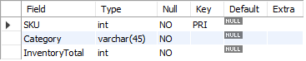

Livestock

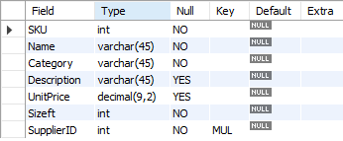

Landscaping

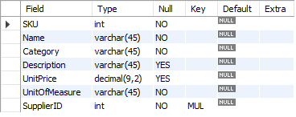

Customers

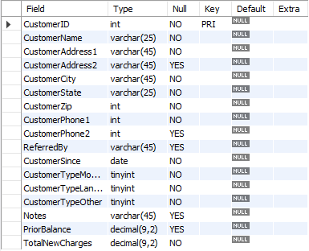

Suppliers

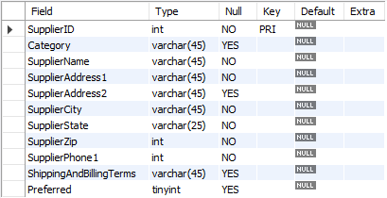

RetailSalesTicket

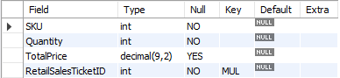

RetailTicketDetails



SQL:

SELECT CustomerName, CustomerAddress1, CustomerCity, CustomerState, CustomerZip, CustomerPhone1, CustomerPhone2

FROM

Customer;

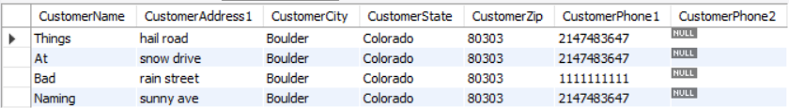

Select L.Category, L.SKU, L.Description, L.Sizeft, I.InventoryTotal

FROM Livestock L, Inventory I

WHERE L.SKU = I.SKU;

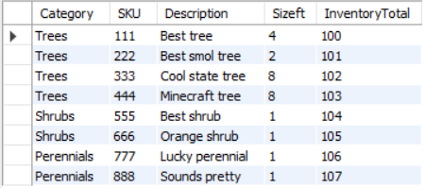

Select L.Category, L.SKU, L.Description, CONCAT(I.InventoryTotal, " ", L.UnitOfMeasure) as QuantityMeasured

FROM LandscapingMaterials L, Inventory I

WHERE L.SKU = I.SKU;

